**Code:**

import matplotlib.pyplot as plt

import pandas as pd

import numpy as np

dataset=pd.read_csv("/content/exp-1_train.csv")

dataset.describe()

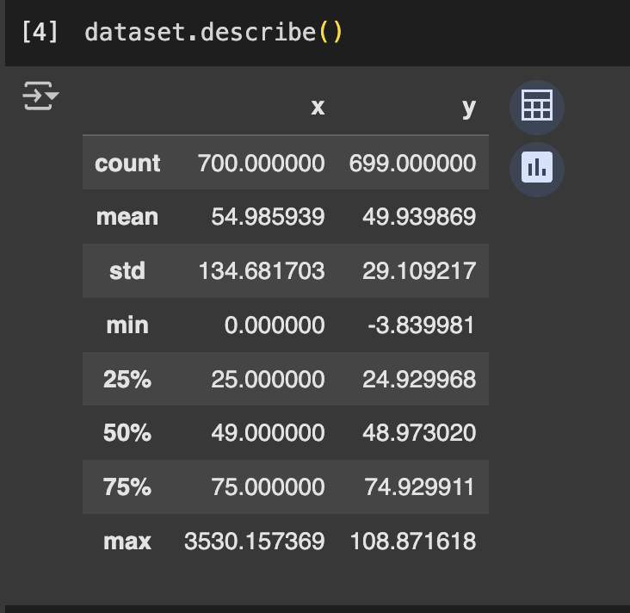

x=dataset.iloc[0:700,0:1]

y=dataset.iloc[0:700,1:2]

x.boxplot(column=['x'])

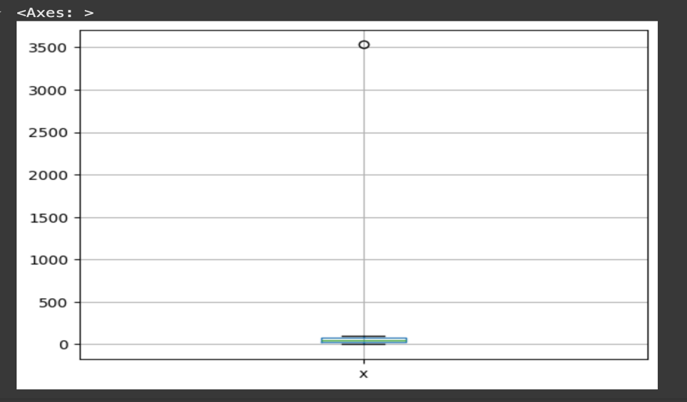

y.boxplot(column=['y'])

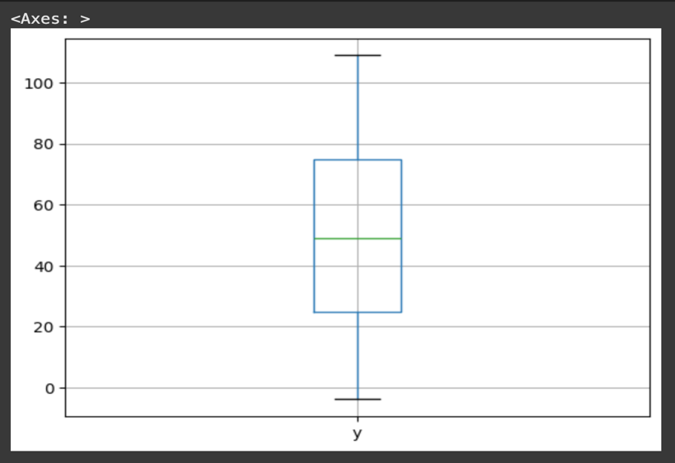

#plot the scatter plot

plt.scatter(x,y)

plt.xlabel('x')

plt.ylabel('y')

plt.title('x vs y scatter plot')

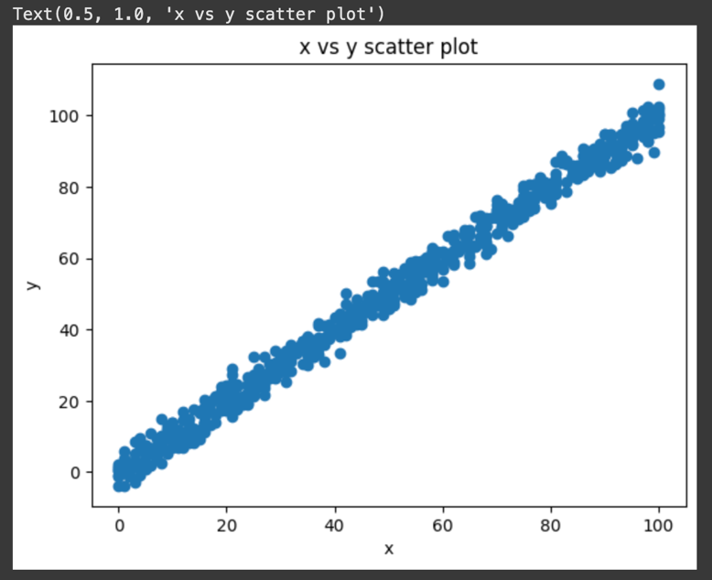

#linear regression

def hypothesis(theta_array,x):

return theta_array[0]+theta_array[1]*x

def Cost_Function(theta_array,x,y , m):

error=0

for i in range(m):

error=error+(hypothesis(theta_array, x[i])-y[i])**2 # Use hypothesis function

return error/(2*m)

def Gradient_Descent(theta_array , x, y , m ,alpha) :

summation_0 = 0

summation_1 = 0

for i in range(m):

prediction = hypothesis(theta_array, x[i]) # Use hypothesis function

summation_0 += (prediction - y[i])

summation_1 += x[i]*(prediction - y[i])

new_theta0 = theta_array[0] - (alpha/m)*summation_0

new_theta1 = theta_array[1] - (alpha/m)*summation_1

updated_new_theta = [new_theta0 , new_theta1]

return updated_new_theta

def Training(x, y, alpha, iters):

theta_0 = 0

theta_1 = 0

cost_values = []

theta_array = [theta_0, theta_1]

m=x.size

for i in range(iters):

theta_array = Gradient_Descent(theta_array, x, y, m, alpha)

cost_values.append(Cost_Function(theta_array, x, y, m))

return theta_array, cost_values # Return theta_array and cost_values

#feesing the input data

Training_data=dataset.dropna()

Training_data.shape

x_value=Training_data['x']

y_value=Training_data['y']

type(x_value)

x_value=x_value.values.reshape(x_value.size)

y_value=y_value.values.reshape(y_value.size)

type(x_value)

alpha = 0.0001

iters = 50

theta_array, cost_values = Training(x_value, y_value, alpha, iters)

x_axis = np.arange(0, len(cost_values), step=1)

plt.plot(x_axis, cost_values)

plt.xlabel("Iterations")

plt.ylabel("Cost Values")

plt.title("Loss Graph")

plt.show()

